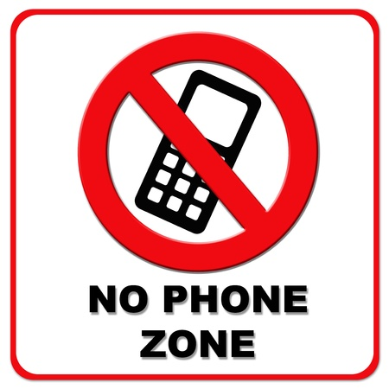

MOBILE
PHONE NOT ALLOWED

